Deploy Backend using python , connect it to RDS DB with Redis Cache .
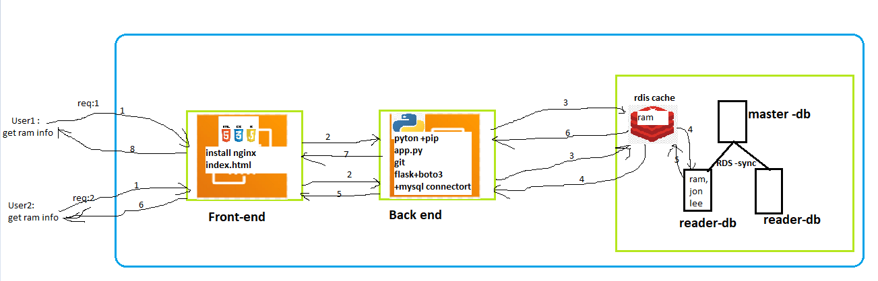

RDS Database configuration
- Create RDS database-1
(public access + public subnet + self-managed password)
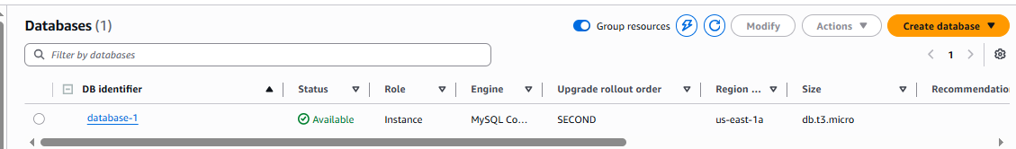

Create read replica . here we are creating it for testing purpose.
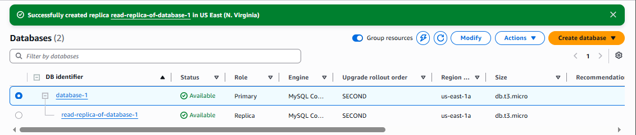
Try to connect with both RDS DB using mysql workbench to check connection
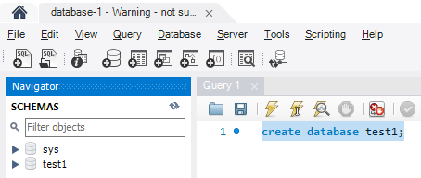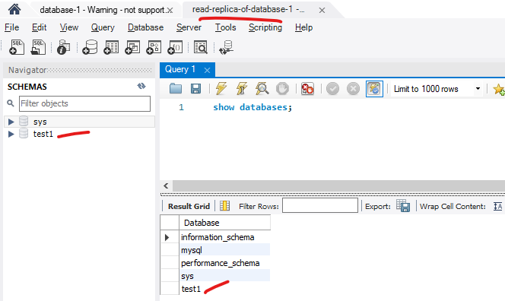
Create a chache for Primary/master DB (database-1).
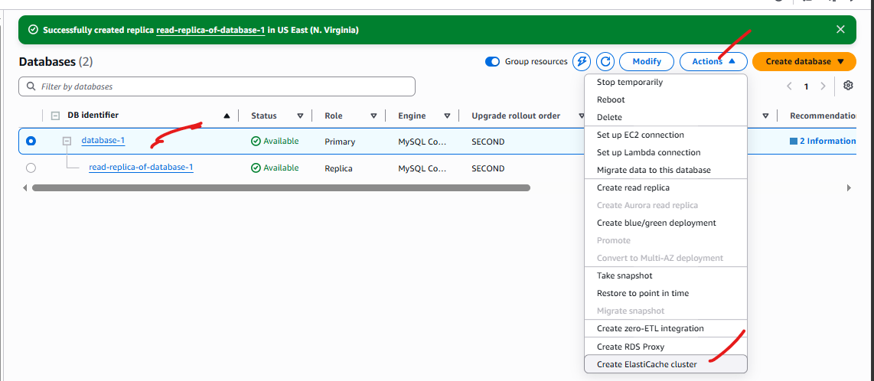
Give a name , select options and create.
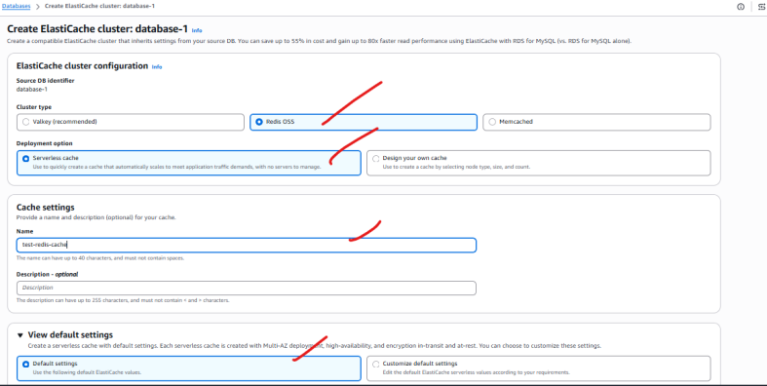
You can find the newly created cache under Elastic Cache
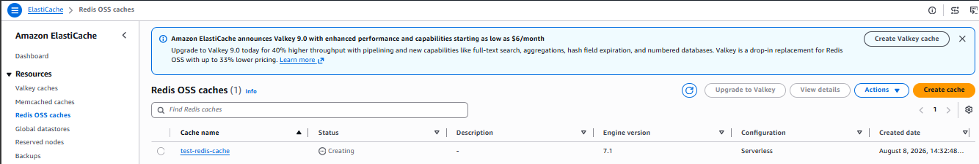

Backend configuration
Create public server and allow all traffic.
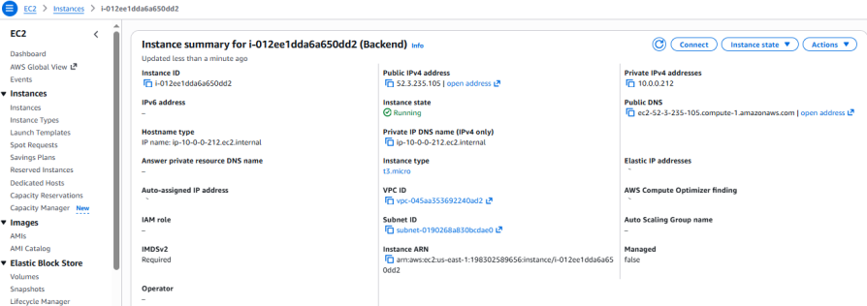

Switch to root >create and move to backend-cache directory>
-Install python + pip
yum install python –y
yum install pip –y
-create a requirement.txt and include backend dependencies .
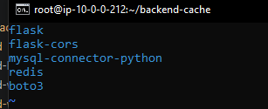
Then execute the command to install dependencies -> pip install –r requirements.txt
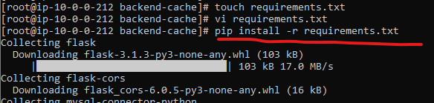

-we can use mysql agent to test , backend to RDS database-1 connection.
a. install agent -> yum install mariadb105 -y
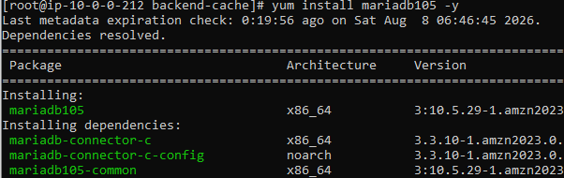
b.use this to connect ->
#mysql -h database-1.c6xkgac6c5dq.us-east-1.rds.amazonaws.com -u admin -p
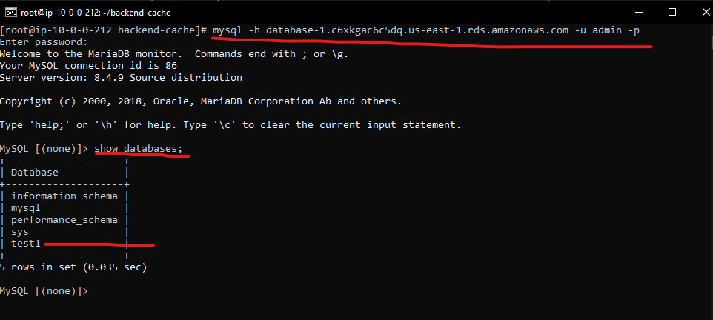
***********
If you want to create or modify the RDS database-1 staying in backend server by using mariadb105 , then you can create a file with .sql extension and include the query that you want to execute .
Got to backend-cache>Create employee.sql [ include ( create database Employee;)]
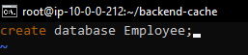
Now execute ->
# mysql -h database-1.c6xkgac6c5dq.us-east-1.rds.amazonaws.com -u admin -p'AdminMukesh' < employee.sql
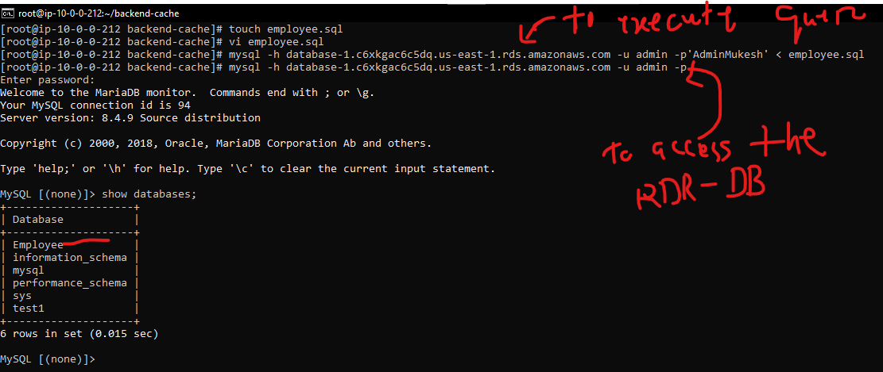
Now create test.sql , include below code and execute .
CREATE DATABASE IF NOT EXISTS dev;
USE dev;

CREATE TABLE users (
id INT AUTO_INCREMENT PRIMARY KEY,
name VARCHAR(100) NOT NULL,
email VARCHAR(100) NOT NULL UNIQUE
);

INSERT INTO users (name, email) VALUES
('John Doe', 'john@example.com'),
('Alice Smith', 'alice@example.com'),
('Bob Johnson', 'bob@example.com'),
('Eve Adams', 'eve@example.com');

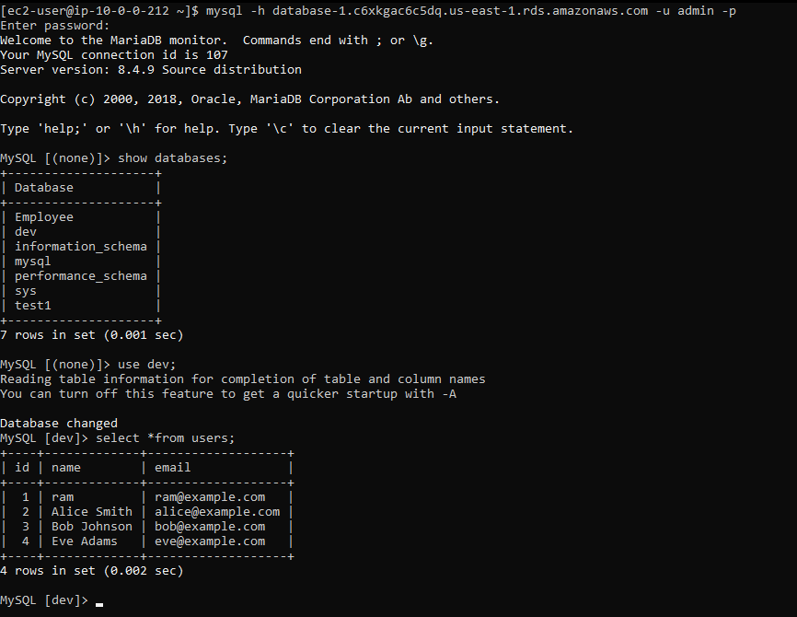

-create app.py or cache.py and include backend code.
In that code Update the metrics
– 1. rds dns
-2 . reader –replica dns
-3 . redis chache dns
In redis cache section .
# =========================
# REDIS CONFIG
# =========================
redis_client = redis.Redis(
host='test-redis-cache-kkfh9h.serverless.use1.cache.amazonaws.com', #rdis dns
port=6379,
ssl=True,
decode_responses=True,
socket_timeout=5
)

CACHE_TTL = 90 #cache retention period

Then run -> Python3 app.py

Now run curl -X Get and observe the source .
Initially the data fetched from RDS reader .
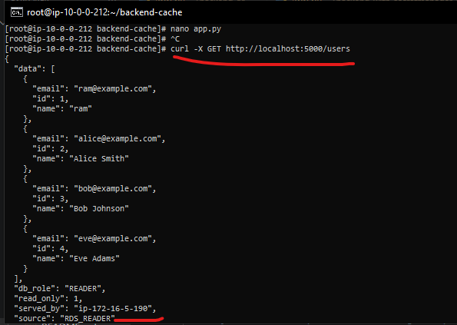
Then again get all user data and observe the source .
When the same data fetched multiple times , the frequently used data stored inside Redis Cache.
And in the next time when the same user or different user tried to access same data ,instead of going to read replica it fetched the data from the Redis cache .
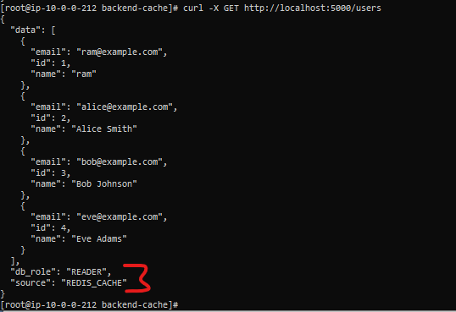

Cache Invalidation –
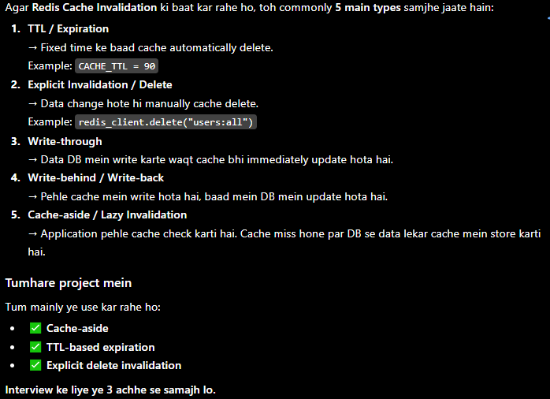

Frontend configuration
Now we can create Frontend server and install nginx .
in inside /usr/share/nginx/html/index.html folder give your front end index.html file
we can configure without proxy or with reverse-proxy.
We can also configure ROUTE53 for the Domain .

